Telerik Software Academy 2012/2013 – CSS Styling Practical Exam – Variant 2

Exam terms – Read carefully!
During the exam you are allowed to use any teaching materials, lectures, books, existing source code, and other paper or Internet resources.
Direct or indirect communication with anyone in the class or outside the room is absolutely forbidden.
You must submit your solutions in http://telerikacademy.com/Courses/Courses/Details/16 as a homework to the lecture titled “CSS Styling Exam – Variant 2”.
You must submit only one ZIP file with the three CSS files, labeled task1.css, task2.css and task3.css.
The trainers will give you a link to download ZIP with the assignments. In the ZIP you will find three folders, titled task1, task2 and task3.
Each of the folders contains a folder titled task-images, an HTML file and empty CSS file, and may contain JavaScript files or other images. Your task is to write the CSS to the HTML file, so that it looks as similar as possible to all the images in task-images folders.
Important: you are not allowed to change the HTML file or the name of the CSS file.
Only your last code submission will be evaluated. You have exactly 3 hours to solve all given problems.

Task 1
- Resolution-width: 960px
- font-family: Helvetica, Arial, 'DejaVu Sans', 'Liberation Sans', Freesans, sans-serif
- font-size: 18px
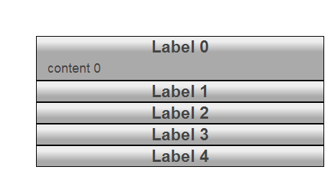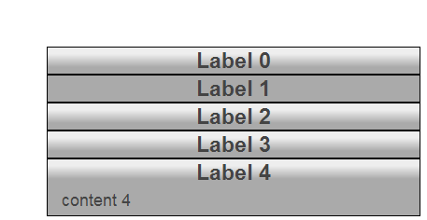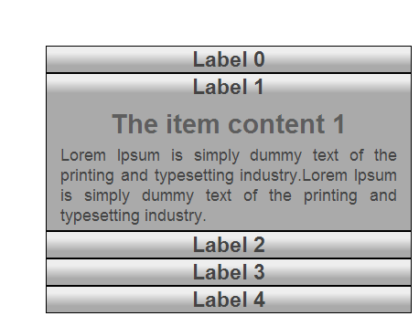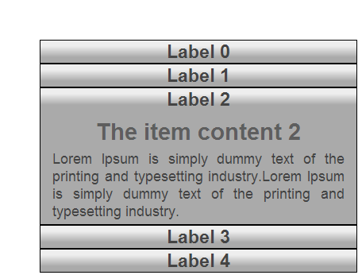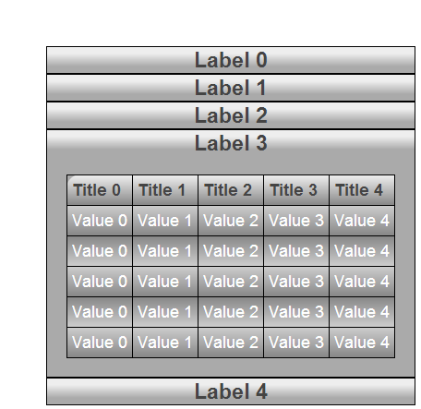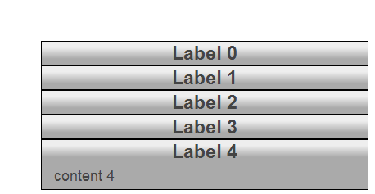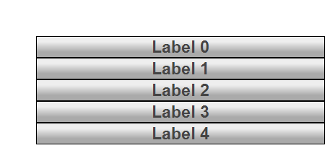

Task 2
- Resolution-width: 960px
- font-family: 'Courier New', Courier, 'Nimbus Mono L', monospace
- font-size: 16px
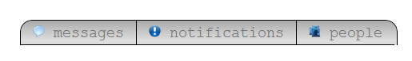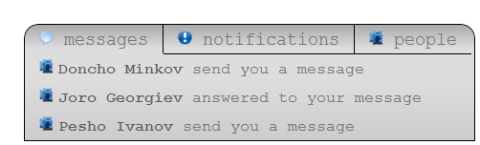
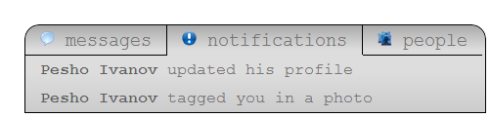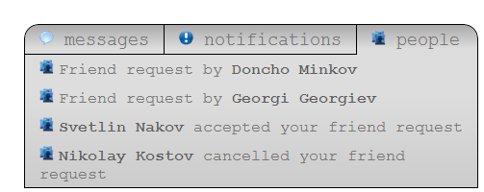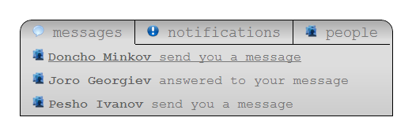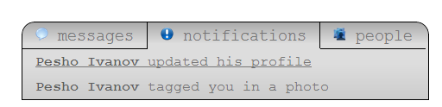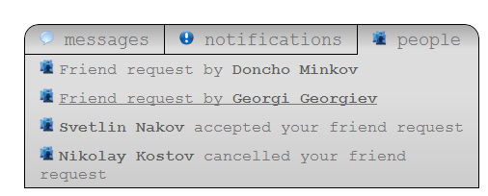

Task 3
- Resolution-width: 960px
- font-family: Verdana, Geneva, 'DejaVu Sans', sans-serif
- font-size: 16px

